NAME: _____________ | Computer Programming
Loops | DATE: Thursday, November 09, 2017
Fill in the missing information
If we want to repeat 365 times
Start at ______ | i = ______
Keep repeating if value is less than ______ or less than or equal to ______  or greater than ______  or greater than or equal to ______ | i < ______  Cross out the ones that don’t apply  i <= ______  i > ______  i >= ______
Each time, should the value go up or down | i ++  Cross out the ones that don’t apply  i --  i = i + ______  i = i - ______
Put it all together

for (int i = _____; i ____________ ; i ________ )

If we to start at 1000 and go down 10 each time until you hit 900
Start at ______ | i = ______
Keep repeating if value is less than ______ or less than or equal to ______  or greater than ______  or greater than or equal to ______ | i < ______  Cross out the ones that don’t apply  i <= ______  i > ______  i >= ______
Each time, should the value go up or down | i ++  Cross out the ones that don’t apply  i --  i = i + ______  i = i - ______
Put it all together

for (int i = _____; i ____________ ; i ________ )

If we want to start at min and go to 50 more than min, and going by interval each
Start at ______ | i = ______
Keep repeating if value is less than ______ or less than or equal to ______  or greater than ______  or greater than or equal to ______ | i < ______  Cross out the ones that don’t apply  i <= ______  i > ______  i >= ______
Each time, should the value go up or down | i ++  Cross out the ones that don’t apply  i --  i = i + ______  i = i - ______
Put it all together

for (int i = _____; i ____________ ; i ________ )

What would get printed out from the following?
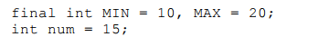
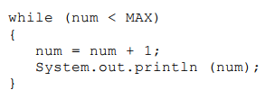
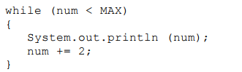
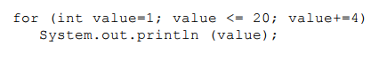

Advanced
